**Superstore Sales & Profit Analysis**

**🔍 Objective:**

The goal of this project is to perform an in-depth analysis of a retail superstore's sales data to uncover insights related to revenue generation, profit distribution, discount impact, and customer behavior. Using Power BI, this interactive dashboard enables data-driven decision-making by visualizing key performance indicators and trends.

**🗃️ Dataset Overview:**

The dataset used in this analysis is the *"Sample - Superstore"* dataset, which contains records of customer orders, including:

* **Order Date**, **Sales**, **Profit**, **Discount**, **Quantity**
* **Customer Segment**, **Region**, **Product Category**
* **Shipping Mode**, **State**, and other transactional details

**⚙️ Tools Used:**

* **Python (Pandas):** Initial data cleaning and preprocessing
* **Power BI:** Interactive dashboard creation and visual analytics

**📈 Key Areas of Analysis:**

1. **Sales and Profit Trends:** Understanding how sales and profit vary across different regions, segments, and time periods.
2. **Profitability by Category/Sub-Category:** Identifying which products contribute most to overall profit or loss.
3. **Discount Impact:** Analyzing how varying discount levels influence profitability.
4. **Customer Insights:** Recognizing top-performing customers and segments.
5. **Shipping & Logistics:** Examining how shipping modes affect cost and delivery efficiency.

**🧠 Conclusion:**

This dashboard acts as a strategic tool to monitor sales health, optimize pricing strategies, and streamline inventory decisions. By visualizing these patterns, business stakeholders can make informed decisions to drive growth and profitability.

1. **Sales by Region**

**Insight:** Which regions generate the most revenue?

**Chart Type:** Bar Chart

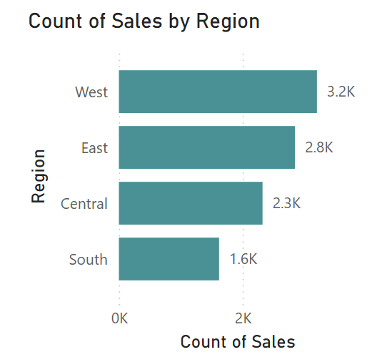

1. **Profit by Category and Sub-Category**

**Insight:** Which regions generate the most revenue?

**Chart Type:** Bar Chart

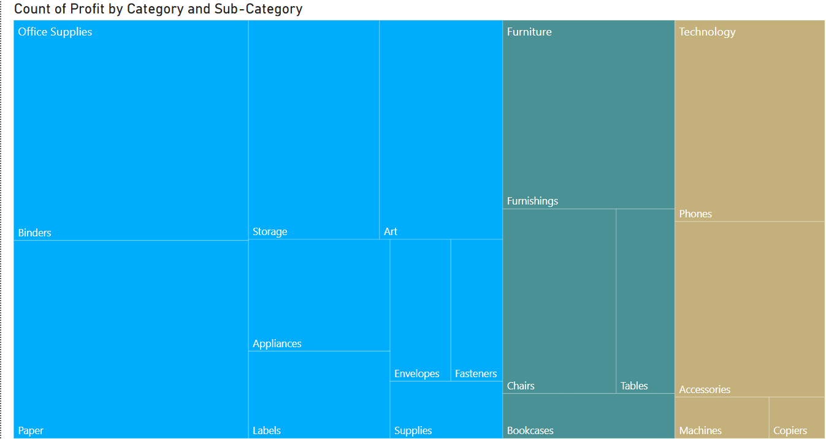

1. **Profit by Category and Sub-Category**

**Insight:** Are high sales always profitable? Identify outliers.

**Chart Type:** Scatter Plot (Sales on X, Profit on Y)

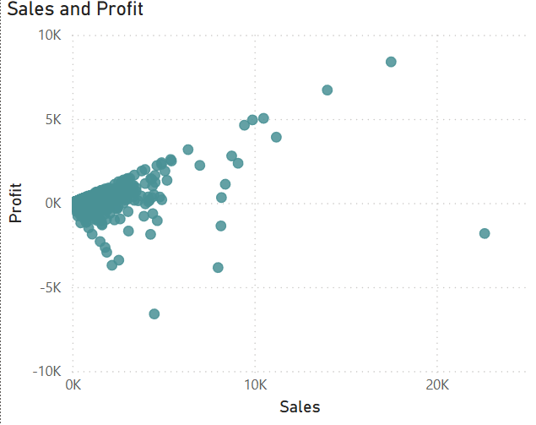

**(1) High Sales ≠ High Profit**

* **Some points with very high sales (10K–20K) are not always paired with high profit — in fact, a few show low or even negative profit.**
* **💡 *This indicates that high revenue doesn't always translate to good profitability — possibly due to high discounts or cost of goods sold.***

**( 2)Negative Profit Zones**

* **There are several data points with negative profit, even when sales are non-zero.**
* **💡 *These may be cases where products were sold at a loss. Could be worth checking if discounts or shipping costs are driving this.***

**(3) Dense Cluster Around Low Sales**

* **A large number of points are clustered in the low sales, low profit zone (under 5K sales and under 2K profit).**
* **💡 *This could suggest most transactions are small-scale — maybe retail-level or low-ticket products.***

**(4) Outliers**

* **A few clear outliers with very high sales and high profit stand out on the right side.**
* **💡 *These could be key customers, product categories, or bulk orders — investigate further for upsell opportunities.***

**(5) Linear-ish Trend**

* **There's a visible positive correlation between sales and profit for many points.**
* **💡 *As expected: generally, more sales lead to more profit — but the spread also shows variability in profit margins.***

1. **Discount vs Profit Analysis**

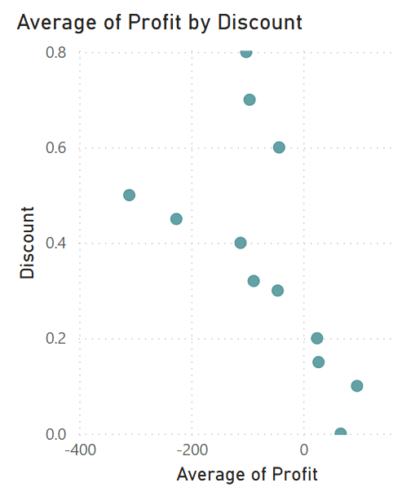

**1. Higher Discounts Lead to Lower or Negative Profit**

* As the **discount rate increases**, the **average profit decreases sharply**, even turning **negative beyond 0.3 (30%)**.
* 💡 *This shows that aggressive discounting is* ***hurting profitability*** *— especially discounts above 30%.*

**2. Optimal Discount Range**

* **0% to 10–15% discounts** still show a **positive or neutral average profit**.
* 💡 *This range might be the "sweet spot" where discounts boost sales without eroding margins too much.*

**3. Very High Discounts (60%–80%) = Heavy Losses**

* Discounts in the **60–80% range** are clearly associated with **large negative profits** (as low as –400).
* 💡 *These discounts might be part of clearance sales or promotions, but they are causing* ***significant financial loss****.*

**4. Negative Correlation Trend**

* There is a **clear downward slope**, showing a **strong negative correlation** between discount and profit.
* 💡 *This is a key data-driven justification for reevaluating current pricing strategies.*